Britain's most beautiful views

Number 1: Pass of Glencoe, the Scottish Highlands
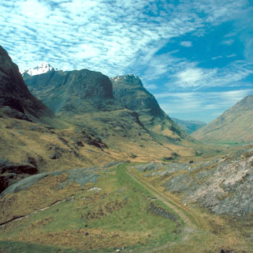
We were expecting some lively disagreements over which view should reign supreme. But one message came through loud and clear from the outset: that any number of Britain’s most beautiful views are to be found in the Scottish Highlands. And there can be few places even in the Highlands quite so magnificent or poignant as the Glencoe Pass. Dramatically shut in on all sides by precipitous mountains, this was the scene of the infamous Massacre of Glencoe in 1692. As Kaylin Krashesky, MSN intern, writes, “I love the Scottish highlands because it is so perfectly serene. It is a place where I want to go retire, sit and write a novel and breathe fresh air.”

Number 2: Wastwater, the Lake District, Cumbria
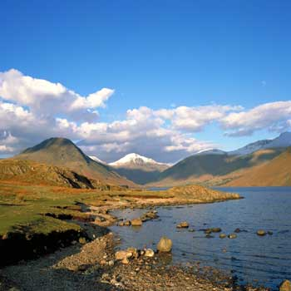
Cumbria is said to capture all the best elements of the Great British countryside: and it has certainly inspired more than its fair share of painters, poets and novelists to wax lyrical about it. To narrow our search down to just one view, we had to pass over a dozen serious contenders. But Wastwater Lake won us over with its rippling hills and often snowy peaks. The writer Alfred Wainwright put it well when he wrote, "Surely there is no other place in this whole wonderful world quite like Lakeland.”

Number 3: White Cliffs of Dover, East Sussex
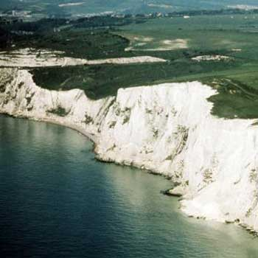
An almost inevitable inclusion, the White Cliffs form one of the south coast’s most beautiful stretches, and have witnessed so much of Britain’s history that they’re forever entangled with the national psyche. But more than that, they’re still a haven of peace, and home to sweeping views across the English Channel. As Jane Douglas, MSN's Tech & Gadgets Editor writes, “Looking down, this view takes in the iconic White Cliffs, lush cliffside woods, a beautiful stretch of the British Channel and, on a clear day, the coast of France. So it’s my favourite view of Britain… and France.”

Number 4: The Giant’s Causeway, County Antrim
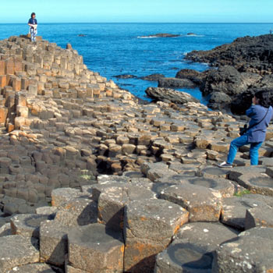
Of course, it always helps to be unique. And the view over this World Heritage Site on Northern Ireland’s Atlantic coastline is certainly that. Great hexagonal columns of rock fit together in rugged symmetry; their unnervingly perfect design forged by volcanic activity 60 million years ago. The surrounding cliffs afford dramatic views, and long walks beckon along the Causeway coastline. David Bellamy writes for the Official Guide, “[This is] one of my favourite places. The jewel in the crown of the fabulous coast of Antrim.”

Number 5: Durdle Door, Dorset
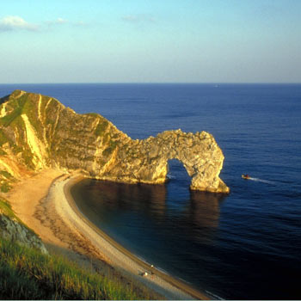
The Jurassic coast of West Dorset is fringed by a rollercoaster of a cliff walk that passes numerous secluded bays and intriguing rock formations – of which the most fondly thought of is dramatically arched Durdle Door. Its all-but-vertical rock strata, and narrow bands of rock, have endeared it as a film set too: it has hosted everything from a Cliff Richard video to the film Nanny McPhee.

Number 6: Bedruthan, Cornwall
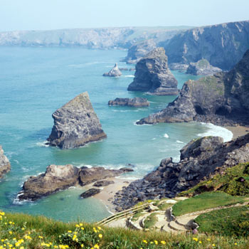
Everyone canvassed for this countdown agreed that Cornwall had to feature somewhere; its craggy coastline could fill a gallery by itself. But which view in particular won through? That of the Bedruthan Steps, on the northern coastline, where erosion has littered the beach with towering outcrops of volcanic rock. Access to the beach is via a steep staircase, for neither the faint hearted nor unfit. Nik Taylor, MSN's Tech & Gadgets Editor, writes “We sat at a tea shop in Cornwall with our cream tea and scone on a nice sunny day, and the view of the ocean was just as though we were abroad.”

Number 7: Three Cliffs, Swansea
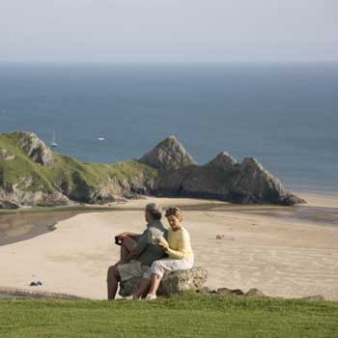
Swansea the city may get a rough press, but Swansea the county is ripe with rollicking good views and fine beaches. And nowhere more so than the coast, including this impossibly picturesque beach in a dune-fringed valley and overlooked by wild ponies and the ruins of Pennard Castle. Thanks to an off-the-beaten-track location, this isn’t a busy beach, but it’s a terrific spot for horse-riding surfing and hiking. As Welsh opera singer Katherine Jenkins told Visit Britain, "Three Cliffs is so intimate and cosy. It gives me the feeling of being hugged. This view has everything - it has the sea, it has the cliffs and the marshes."

Number 8: The Needles, the Isle of Wight
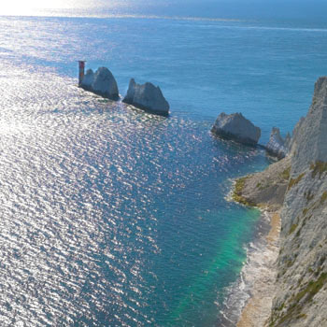
Another popular choice, this finger of toothy stacks juts defiantly out from the western Isle of Wight’s chalky-white cliffs. Despite dissolving steadily into the sea, along with the cliffs they were carved from, these stacks still make an enchanting view – their whiter-than-white faces contrasting against the deep blue of the surrounding sea on a sunny day. The Needles are never more spectacular than during the world-famous sailing regatta Cowes Week, when a hundred crisp white sails surround the stacks. Charlotte Amelines, MSN's Travel Editor writes, “The Needles have always summed up the chalky south coast of England for me, ever since learning to sail around and all-too-nearly into them as a child.”

Number 9: The Wye Valley, Herefordshire
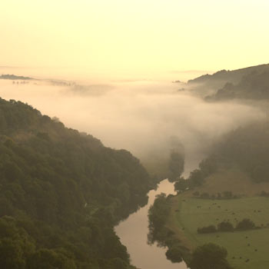
A view is about more than just a static postcard image. It should encompass a living landscape, and the Wye Valley scores highly on our list for its all-round beauty, tranquillity and rich wildlife. It’s best viewed from a canoe – of which there are many for hire. As Tom Levitt, MSN's Environment Editor puts it, “Rowing along the River Wye, what could be more tranquil or indeed British? You pass through some of the most beautiful country views in the whole British Isles – Monington falls, Symonds Yat and countless nameless fields. Loads of wildlife and no noise. Perfect!"

Number 10: Rush Up Edge, the Peak District, Derbyshire
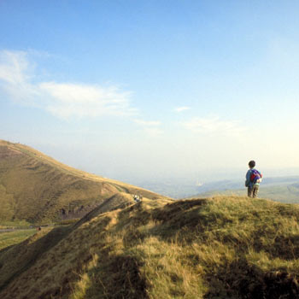

Created in 1951, Britain's first national park is still one of the country’s first ports of call for climbing, caving, walking, cycling – and of course, stunning views. There is a wealth of panoramas to pick from, but our experts have a particular soft spot for the 360° views from atop Rushup Edge, a long ridge that reaches 546m high, with Mam Tor at its eastern end.

