Part I. Research Track Record

Principle investigator: Richard Fu has been working in the areas of MEMS and microengineering in Nanyang Technological University, Singapore, Singapore-Massachusetts Institute of Technology Alliance, and University of Cambridge, UK for the past ten years. In Sept 2007 he joined Heriot-Watt University in Edinburgh as a lecturer on microengineering and bioengineering. Dr. Fu’s recent research work is focused on microsensors and microfluidic devices, based on smart functional thin films (such as piezoelectric and shape memory thin films, diamond, nanocomposites, etc) [] (see Fig. 2). Of particular relevance to this application is his work on surface acoustic wave (SAW) ZnO devices, in which he has demonstrated that the ZnO SAW devices can be used for microfluidic and biosensing applications []. Dr. Fu has about 140 refereed international journal papers and more than 60 international conference papers, as well as three book chapters and one authored book being published. He has been invited as a regular referee for over 25 different international journals, and has been invited to serve on two international conference organization committees and is an editorial board member of an international journal. He has gained much experience in research project management and has established many links with research institutes around the world, including the UK, Europe, Singapore, China, Japan and Korea.

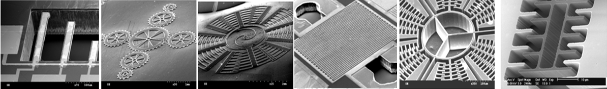
(a) (b) (c) (d) (e) (f)
Fig. 2. Dr. Fu’s work on MEMS (a) PZT cantilever; (b) diamond microgear; (c) diamond microrotor; (d) microvalve; (e) Si gyroscope; (f) silicon accelerometer [1]

Co-Investigator: Gerard Markx is a Professor of Bioprocessing at Heriot-Watt University, Edinburgh and founder and leader of the Microstructures and Microenvironments Research Group. The Research Group prides itself on the highly interdisciplinary nature of its research and the highly multidisciplinary background of its members. Research within the Group concentrates on the investigation of spatial structure in biological materials at the microscale, looking at how it emerges, how it can be artificially created, and what consequences it has on cell growth and activity. The group has strong expertise in the use of microfabrication technology in biological systems and the 2-D and 3-D organisation of cells within films, aggregates and tissues, using a variety of cell culture, physical cell micromanipulation and cell immobilization techniques (see Fig. 2) []. The research group has particularly strong expertise in the study of the AC dielectric properties of cells and its applications, and has pioneered the use of dielectrophoresis for the creation of cell aggregates with defined internal architectures, and its use for the study of cell-cell interactions. Funding sources to date have included the BBSRC, EPSRC, Wellcome Trust, NATO, Royal Society, Nuffield Foundation, industrial sources, and others. BBSRC funded projects have included the investigation of the formation of biofilms with defined internal architectures (grants 36/E15770 and 36/E11566), and more recently the construction of artificial haematopoietic stem cell microniches (grant BB/D002850/1). Collaborative projects with industry have included projects with Aber Instruments Ltd on the development of dielectric spectroscopy techniques, and Intercytex Ltd on tissue engineering. Prof Markx is named inventor on 3 patents.

Fig. 2. Highly impact images of Gerard’s work on bioprocessing

The School of Engineering and Physical Sciences at the Heriot-Watt University offers a multi-disciplinary environment with researchers in Mechanical, Electrical, Chemical Engineering, Physics and Chemistry. The School has a clean room including many micromachining and packaging facilities, which can be used for this project. The Department of Mechanical engineering has recently invested in many micro/nano characterisation facilities under SRIF (What is SRIF???) funding. Significant SRIF funding has also been used for acquiring facilities for work at the Life-Science/Engineering Interface, which comprise upstream facilities for bacterial and animal cell culture feeding into a common downstream processing area. Research in bioprocessing and biothrapeutics was recently identified as one of key research themes that the university will look towards developing for future research excellence.
Co Investigator Anthony J. Walton is professor of Microelectronic Manufacturing in the School of Engineering and Electronics at the University of Edinburgh and Director of the joint research institute (IIS: Institute of Integrated Systems) in Edinburgh. He has been actively involving with the semiconductor industry in a number of areas associated with microelectronic test structures, MEMS, yield improvement, design for manufacturability and technology computer aided design, with some of his work shown in Fig. 1. His present interests include microfluidics based on EWOD, the applications of micro and nanotechnology to biotechnology, MEMS technology and packaging and digital microfluidics [], and integration of new technologies (such as MEMS) and materials with foundry CMOS. He has published over 200 papers and has won the best paper awards for the IEEE Transactions on Semiconductor Manufacturing, Proc. International Society for Hybrid Manufacturers (ISHM) and the International Conference on Microelectronic Test Structures (ICMTS). He has served as the chairman for a number of conferences which include the European Solid-State Devices Research Conference (ESSDERC) and the IEEE International Conference on Microelectronic Test Structures (ICMTS). He also serves on numerous technical committees and is an associate editor of the IEEE Transactions on Semiconductor Manufacturing and the Journal of Nanoengineering and Nanosystems.
Prof. Walton played a key role in setting up the Scottish Microelectronics Centre (SMC) which is a purposely built facility for R&D and incubation of many companies. Scottish Microelectronic Centre in University of Edinburgh has an excellent reputation in research. The SMC is a world class Centre for Incubation, Research & Development in the semiconductor sector. A joint venture between The University of Edinburgh, and Scottish Enterprise, Edinburgh & Lothian, it provides a dynamic environment that links academia and hi-tech companies. This successful collaboration is at the leading edge of Scotland's semiconductor and MEMS activity. It consists of approximately 300m² of class 10 cleanrooms and 1000m² of office and laboratory space, which can be used for the fabrication work in this research proposal.

Fig. 3. Highly impact images of Anthony’s work on IC and MEMS

The above investigators are from the Institute of Integrated Systems (IIS) under Edinburgh Research Partnership (ERP). IIS creates synergy between existing teams with established international reputations building ‘towers of excellence’ in bio-photonic and bio-electronic systems, high-value manufacturing technologies, miniature-system integration and advanced photonic devices and systems. IIS staff has many internationally-recognised researchers in innovative, low-power VLSI design, novel computational paradigms, advanced silicon device fabrication, optical science and technology, photonics devices and systems (including sensors, lasers and displays), MEMS, micro-machining, laser-based processing and ultrafast/nano-optics. They have complementary skills and technology capabilities, which provides the IIS with opportunities to address research topics that would be impossible on an individual basis. The IIS strategy is to exploit existing strategic relationships with local, UK and international academic institutions and industries (generally in the technology sector, from defence and aerospace to pharmaceutical) to establish a world-class JRI supported by a broad funding base from Research Councils, Space Agencies, Industry, Charities and Government.
Co-Investigator Andrew Flewitt is a senior lecturer in Center for Advanced Photonic and Electronics (CAPE) in Cambridge University. Cambridge University has an excellent reputation in research. CAPE has a world-class cleanroom housed with microfabrication facilities for fabricating microdevices with feature sizes down to< 0.5μm; various thin film deposition and etch systems. Dr. Flewitt’s research interests include the degradation mechanisms of amorphous silicon thin films transistors and the production of polycrystalline silicon thin films at low temperatures. More recently, research activities have included the study of MEMS. Of particular interest is the integration of silicon with plastics in devices and the development of novel materials (such as diamond-like carbon) and associated processing techniques for devices []. He also has a research interest in the production of silicon and ZnO nanowires for communication and microelectronic applications. He is currently Principal Investigator for several (???, how many) EPSRC and EU funded and Nokia funded projects on MEMS, advanced materials, and nanotechnology. Together with the PI, they have done the pioneer work using ZnO SAW devices for microfluidics and sensing applications, which have accumulated substantial experiences in developing the fabrication technology for this research proposal.
This research proposal has also obtained the strong supports from the following companies, hospitals and research centers: XXXXX. The supporting letters have also been provided.

Case for support:

A digital microfluidic sensing platform integrating electro-wetting-on-dielectrics and acoustic wave technology

Abstract: The project aims to develop an integrated digital microfluidic bio-detection platform integrating electrowetting-on-dielectrics (EWOD) and acoustic wave technologies with functions of microdroplet generation, transportation and bio-detection, and advantages of high through-output, full automation, highly integrated lab-on-chip device based on mass production and low cost IC/MEMS fabrication technology.

Background
The increase in demand for fast, cheap and sensitive bio-detection micro-devices has been relentless, for such applications as self-diagnosis or personal health monitoring, rapid detection of contagious diseases (such as influenza, SARS and bird flu), and counter-actions against bioterrorism. These devices can further increase the utilise of limited public health resources by cooperating with the Geographic Information Systems (GIS) and disease mapping systems which could promise to fast locate, track and prevent disease outbreaks [].
The main challenge in developing such bio-detection systems is to find efficient, sensitive and low cost technologies which can fulfil the basic microfluidic and biosensing functions. The normal procedures for biosensing or disease diagnosis based on DNA and protein technologies include []: (1) generation and transportation of microfluid with DNA/protein into an area which has been pre-deposited with bio-binder, (2) mixing/reaction of the extracted DNA or protein with oligonucleotide or the antibody binders, and (3) detection of an associated change in the physical, chemical, mechanical or electrical signals. The recent development of lab-on-a-chip or micro-TAS (Total Analysis Systems) which integrate the functions of sample preparation, transportation, DNA hybridization, and electrochemical detection on the same micro-chip is one possible future direction []. However, the challenge is still remained to find the efficient, sensitive and low-cost technologies which can fulfil all the essential functions: microfluid or micro droplet generation, transportation, mixing/bio-reaction and detection, in order to reduce device size and cost, and also to enhance the performance and sensing accuracy. One novel idea for this proposal is to exploit the integration of electrowetting-on-dielectrics (EWOD) and acoustic wave technology using IC/MEMS fabrication.
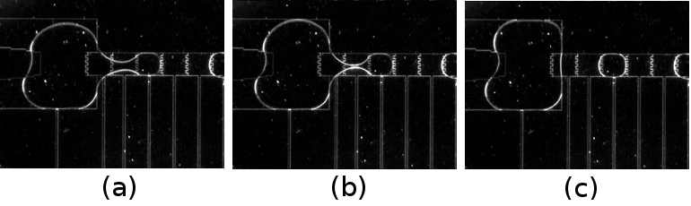
Liquid in reservoir
Droplet dispensing from reservoir
Fig. 4. Top view of an EWOD device, showing (a) a 1 micro litre droplet on the reservoir electrode is being pulled out onto a small electrode array. (b) both the reservoir electrode and a small electrode are switched on to pull both sides of the liquid to split it. (c) 80 nano litre droplet is dispensed after the splitting
Fig. 2 (a) to (c) shows two droplets merged together. (d) to (f) shows a droplet split into two droplets
(Yi Fan: Pls. modify the above figures, I need three photos for a sequence on the same line, i.e., a, b c on the same line, and (d) (e) (f) on the same line, pls. do not use (a) (b) (c) in the photos, we can add them separately)..

EWOD technology enables droplet manipulation (creation, transportation and mixing) by using electrical energy to alter the surface wettability. In the past ten years, the EWOD technology has been successfully developed to perform programmable fluidic functions such as droplet creation, transportion, cutting and merging []. EWOD devices normally consist of an array of metal electrodes and interconnect, coated with an insulating dielectric layer and a layer of hydrophobic material such as Teflon. Unlike microchannel devices, EWOD devices manipulate fluids actively without external pressure sources. Without any movable mechanical parts, EWOD devices have high yield and reliability compared to conventional microfluidic devices that consists of micropump and microvalve. It can be fabricated on various substrates, such as silicon, printed circuit board, CMOS chip and glasses [4,,,], using photolithography method that can be cost effectively mass-produced. Prof. Anthony Walton’ group has been working on the EWOD technology for the past a few years and has successfully integrated EWOD technique into CMOS technology to realize on-chip droplet creation and transportation which can be used as a droplet dispenser and an automatic sample preparing and sorting platform. The driving voltage of the EWOD device has been lowered to 15V using a robust Ta₂O₅ technology [Error: Reference source not found]. Figure 4 shows that microdroplet dispensing or creation, merging and mixing functions can be easily realized on a CMOS chip with standard CMOS fabrication process [,]. However, EWOD technology does not provide efficient micro-mixing and biosensing functions.
One promising technology for both the microfluidic (mixing/pumping) and biosensing applications is surface acoustic wave (SAW). There are many studies of microfluidics devices using SAW technology and bulk materials, such as LiNbO₃ and quartz []. The applicants (including the PI, Dr. Fu and Co-I, Dr. Flewitt) have done pioneer work on the ZnO film based SAW microfluidics and biosensors [2]. By applying an RF signal to an inter-digital transducer (IDT, see Fig. 5a) on a piezoelectric material (for example, ZnO film), a surface acoustic wave (SAW) can be generated which propagates along the surface. When the acoustic wave encounters liquid droplets on the surface of a SAW device, the energy and momentum will be coupled into the fluid, causing acoustic streaming and efficient mixing of the liquids (Fig. 5b) [2]. If the power is large enough and the film surface is hydrophobic, the liquid can be pushed forward (Fig. 5c). ZnO SAW device has also been used as a biosensor, and the principle for biosensing is based on the fact that attachment and reaction of a small quantity of a target molecule with the pre-deposited antibody can lead to a significant shift in the resonant frequency of the surface propagating wave. Advantages of using ZnO SAW devices for microfluidics and bio-sensing include simple in structure and efficiency (as only one operation mechanism is used), low cost (as it is thin film /MEMS based and only one mask is used to fabricate IDT electrodes for all components).

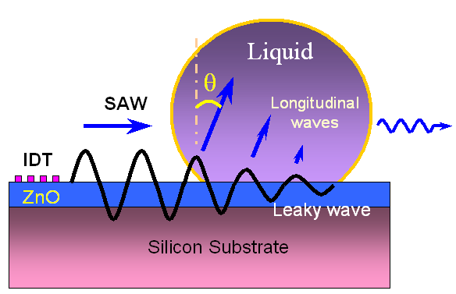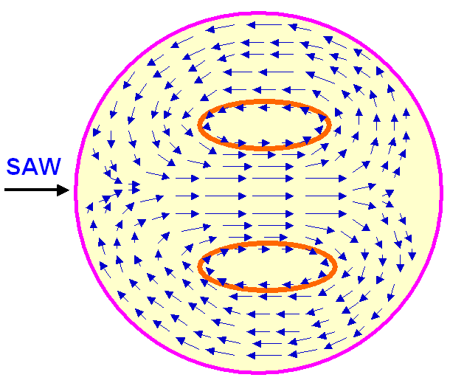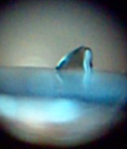
(a) (b) (c) (d) (e)
Fig. 5. (a) illustration of SAW wave energy coupling with the liquid droplet; (b) Interaction between SAW and a liquid droplet resulting in SAW streaming (top view); (c) deformation and moving of microdroplet on the ZnO device surface under SAW wave (cross-section view) [7], (d) A common FBAR device with a membrane structure; (e) A common FBAR device with acoustic mirror beneath

Compared with SAW device, film bulk acoustic resonator (FBAR) has a much higher sensitivy in biosensing []. A common ZnO based FBAR design is shown in Fig. 5d, i.e., a piezoelectric film (ZnO) membrane deposited between two metallic layer electrodes. Because of the much-reduced base mass (membrane), the attachment of very small mass of molecules can cause a very large frequency shift. The FBAR wave can have a high frequency in GHz range. The sensitivity of the acoustic devices increases with the square of the frequency, thus the FBAR device should have very high resolution. However, the fragile membrane and difficulty in making membrane structures are big concerns. Apart from the membrane based FBAR structure, there is another common FBAR design using an acoustic mirror, which is deposited between the piezoelectric layer and substrate (see Fig. 5e). The acoustic mirror is composed of many quarter-wavelength layers of alternating high and low acoustic impedance films. Due to the high impedance ratio of the acoustic mirror, acoustic energy can be reflected and confined inside the top piezoelectric layers, thus maintaining an excellent resonant bandwidth. This design has a better mechanical robustness and a simpler process control compared with the membrane-type designs. Also glass or plastics can be used as the substrates.
In brief, EWOD device is efficient to create and precisely manipulate the droplets, but it does not provide good mixing and sensing functions, whereas acoustic wave based devices (SAW and FBAR) are suitable for efficient mixing, pumping and biosensing, but difficult to generate and precisely move liquid droplet. Based on extensive literature survey, market survey and the applicants’ previous work, a novel concept is proposed to develop a digital microfluidic based lab-on-chip bio-detection platform by using ZnO film and integrating EWOD, SAW or FBAR devices, combining the functions of microdroplet transportation, mixing and bio-detection with advanced IC/MEMS technology. Such an integrated digital microfluidics device (manipulation of a microdroplet) has advantages of (1) easy integration with IC fabrication; (2) programmable and reconfigurable design, control and operation; (3) no channels and valves, thus no dead volume in the system.

2. Aim and Objectives
The aim of this project is to demonstrate a novel microfluidic bio-detection platform, integrating EWOD and advanced acoustic wave technologies based on advanced piezoelectric film. The platform will combine the functions of microdroplet generation, transportation, mixing and bio-detection in a way that it can be used as a development tool for micro-diagnostic systems.
The main objectives for this proposal include:
- To fabricate and characterize the EWOD devices for microdroplet creation, manipulation and transportation;
- To fabricate and characterize the SAW and FBAR devices for droplet transportation and biosensing;
- To integrate the EWOD with acoustic devices to demonstrate novel microfluidic bio-detection platform.

3. Programme and Methodology
3.1. Substrate and characterization
Two types of piezoelectric materials will be used in this study. The first one is the commercial bulk piezoelectric material of LiNbO₃ and the second one is ZnO thin film. ZnO film will be sputtering-deposited using Zn target in a mixture of Ar and O₂ atmosphere, and will be carried out in University of Cambridge. The piezoelectric properties, coupling coefficient and acoustic impedance depend on the crystal quality, film texture, grain size, and resistivity of the films. The film stoichiometry is critical for good piezoelectric effect. X-ray photoelectron spectroscopy and ellipsometer will be used to characterize the Zn/O atomic ratio. The film crystal quality, texture, stress, mechanical and electrical properties of the ZnO films will be characterized using various advanced techniques.

3.2. Work package 1: EWOD technology
The EWOD devices will be fabricated on two types of substrates, i.e., bulk LiNbO₃ substrates and ZnO film on silicon substrates. A major challenge is how to design, pattern and integrate the EWOD and ZnO SAW devices, in order to minimize the potential interfering between the EWOD and SAW signals. The bottom electrodes of Ta (or Al) will be deposited and patterned on the substrates using magnetron sputtering and lift off methods. An insulating dielectric layer will be deposited on the bottom electrodes and substrate. Potential candidates will be vapour deposited Parylene-C or anodic Ta₂O₅ both at room temperature. The thickness and pattern designs of the metal electrodes will be studied in details. The EWOD surface will be treated to be hydrophobic, using spin-coating a layer of Teflon. Fig. 5 illustrates the designed EWOD structures used in this proposal. The EWOD electrode arrays will be designed to realize the microfluidic functions such as (1) droplet generation from liquid reservoir; and (2) droplet transportation.

3.2.1 Droplet generation
In EWOD systems, generating droplets from a sample reservoir can be achieved by switching several electrodes in sequence with precise volume control [2] in two-plate EWOD systems. However, in this typical configuration, there are several limitations such as the ratio of gap size between two plates to the electrode size, droplet necking distance, and liquid characterisation (surface tension, viscosity etc.) [2]. New EWOD designs based on Fig. 5 will be studied in order to accommodate these limitations in the system. A novel configuration of sample liquid introduction system will also be developed to pump the liquid into the device reservoir (a microneedle technology is proposed). A new dispensing process will be developed to pump the liquid into the platform. Different biological liquid samples will be used to verify this new design

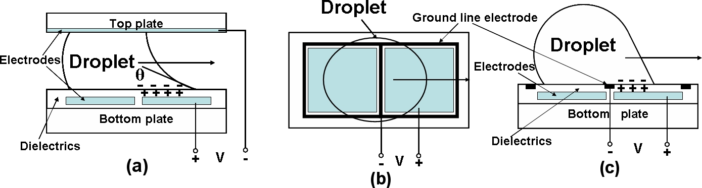
Fig. 5 EWOD designs which can be integrated into the system (a) Top view and (b) Side view of a EWOD device with electrical signal applied to electrodes coplanar on the bottom plate. (c) and (d) SAW devices.

3.2.2 Droplet transportation
The transportation of different liquid samples in EWOD systems has been demonstrated in a variety of devices in different conditions such as droplet in air and droplet in oil [2]. However, system optimisations such as electrode pattern design and driving voltage minimisation, AC/DC driving frequency selection, are still not fully understood. This investigation will aim at a minimised system with simple and limited control circuit to prevent the potential problems, such as protein stiction, movement hysteresis, dielectric breakdown and sample degradation, etc. The effect of liquid viscosity, bio-substances and particles inside the droplets will be studied in detail.

3.3. Work package 2: SAW and FBAR device
3.3.1. SAW device for microfluidics
A SAW device can be fabricated on a LiNbO₃ substrate by patterning of Al IDTs using a lift-off method with a design shown in Fig. 5 (d). For fabrication of the ZnO based SAW device, the ZnO film will be deposited on SiO₂/Si substrates, with SiO₂ being used as an insulating layer. On top of the ZnO film Al IDTs will be made using a lift-off method, thus forming the SAW device. For microfluidic testing, an RF signal will be obtained from a signal generator, and then amplified by a power amplifier and/or a function generator before applying to the IDTs of the ZnO SAW devices. The SAW will be generated and propagates on the ZnO SAW device, thus causing the acoustic streaming, mixing or pumping of the liquid droplet. For efficient liquid droplet pumping, the film surface will be hydrophobically treated with Teflon-AF solution. Based on the preliminary work done by the PI and Co-I (Dr. Flewitt), the new topic in this proposal will include: (1) the effect of applied power or voltage on the pumping rate and velocity; (2) droplet volume and fluid nature (viscosity) on the micro-fluidic pumping; (3) precisely control and efficiently realize the droplet movement and positions using a pulsed wave; (4) new design of the IDTs to enhance the performance, including split fingers, reflectors, or curved IDTs.

3.3.2. SAW and FBAR device for biosensing
FBAR device will only be fabricated using the ZnO film, based on design in Fig. 2c. Silicon nitride will be deposited onto a Si wafer, followed by a multilayer of pairs of sputtered tungsten and silicon oxide thin layers as the acoustic mirror layer. Above this acoustic mirror layer, the bottom electrode (Cr/Au) will be deposited, followed by deposition of the ZnO films and the top electrode (Cr/Au) layer.
ZnO SAW and FBAR devices will be used for biosensing tests. For a simple model bio-sensing test, a commercial prostate cancer marker, prostate-specific antigen (PSA) will be chosen as the target molecule. Gold (Au) is pre-deposited on the surface area between a pair of IDTs of the SAW device; or on the FBAR device’s top gold electrode. Au is the most common material for deposition of antibody, and a cystamine surface atomic monolayer (SAM) can be easily formed on the Au surface. Antibody of PSA can be attached on this cystamine SAM. The bio-specific reaction between PSA and its antibody can be detected by measuring the shifts of resonant frequencies using network analyzer. If the PSA antigen is coupled to fluorescein, binding can be cross-checked by a fluorescence microscopy. Specificity of binding can be tested by using a competitor protein such as BSA coupled to an alternative fluorite such as Texas red. The results on the sensitivity, selectivity and detection limit will be studied. Once the bio-detection method is proven using PSA and its antibody, it can be easily extended to detect other types of antibodies and antigens.
One challenge is that the potential thermal generation (or acoustic heating) during wave propagation and its effect on the biological solutions and performance of the acoustic devices. Theoretical analysis and experimental work will be performed to study this effect. A pulsed wave mode will also be exploited to minimize this effect. A potential risk here for the ZnO based SAW devices, if the film defect level is sufficiently high as to cause significant heating the droplet could be going to evaporate. Therefore, every effort will be made to prepare high quality ZnO films.

3.4. Work package 3: Integration of EWOD and SAW
One big challenge for this proposal is how to precise control of sample sepeartion. The following work will be focused on the design of the bio-detection platform integrating the EWOD and SAW microfluidics and bio-sensing functions on one chip. The planar design of the integrated diagnostic system is illustrated in Fig. 2c. The detailed procedures can be summarized as follows: (1) From the water reservoir on the Si chip, small liquid droplet can be created, separated and transported by EWOD;. (2) After the liquid droplet has been transported to a certain position, a SAW device A (see Fig. 3a) is designed to transport or pump the droplets to where the biobinders are located (i.e., the area between the SAW devices of D and E in this design). (3) The micromixing and reaction of bio-binder and protein can be realized either by a SAW device A or by a pair of SAW devices D and E as shown in Fig. 3a. The mixing can speed up the reaction and reduce the immuno-reaction time. (4) Once the reaction process completes, SAW device A (see Fig. 3a) will generate a wave to drive the liquid waste away. The resonant frequency shift due to the attachment of the target biological molecule will be monitored using the SAW devices D and E using a network analyzer. Two pairs of SAW devices can be fabricated near to each other, so the neighbouring devices on the same substrate will act as sensor-reference combinations. The other pair of SAW devices (for example, B and C in Fig. 3a) without surface treatment with pre-binder can be used as a reference. Temperature drifts or other interference of the SAW sensors can be minimized with this pairing system.
Initial work needs to demonstrate the functions of successive pumping and then sensing on this integrated device using the ZnO based SAW devices. However, there are three potential issues to be solved: (1) the influences of EWOD electrodes on the SAW propagation (insertion loss etc.); (2) Droplet behaviour over topology of the transportation path; (3) the potential interaction between EWOD and SAW signals.

3.5. Work Package 4: Integration of EWOD and FBAR devices
The work in this package will be focused on the design, fabrication and test of the bio-detection platform integrating the EWOD microfluidics and FBAR bio-sensing functions on one chip with a planar design. The planar design of the integrated diagnostic system is illustrated in Fig. 2b. EWOD will be used to generate and drive the microdroplets to the reaction area, and the FBAR device will be used for bio-sensing. The detailed procedures can be summarized as follows: (1) From the water reservoir on the Si chip, small liquid droplet can be created, separated and transported by EWOD to the top of FBAR device. (2) The FBAR device will be used for biosensing, and the antibody bio-binder will be deposited on top of the FBAR device. The molecules in the bio fluid will mix/react with the pre-binder. The shift in the wave frequency due to the mass change caused by the binding of the target biological molecule with the antibody pre-binder will be detected by the FBAR devices. The potential problems and risks include: (1) interaction between EWOD electrode and acoustic wave; (2) possible fabrication incompatibility. Much effort will be made to design a suitable fabrication process and arrangement of different devices.
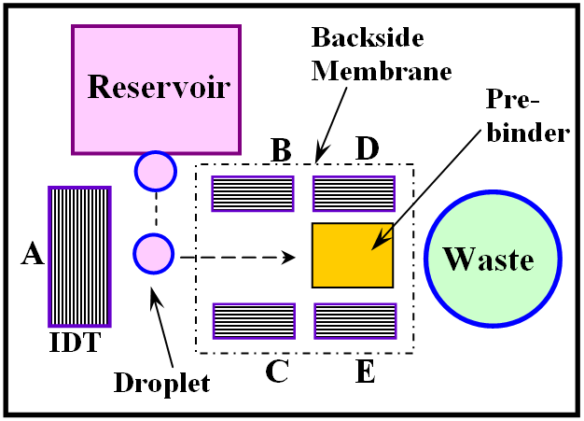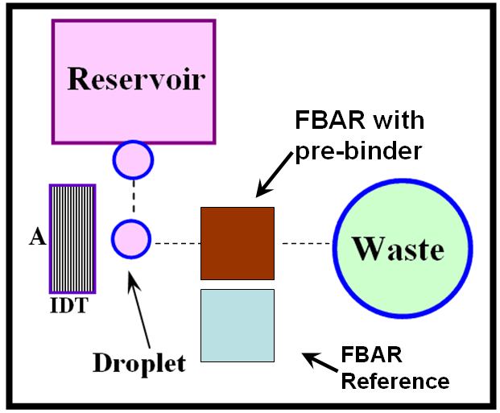
(a) (b)
Fig.3. (a) Proposed integrated digital microfluidic diagnostic chip; (b) an integrated diagnostic device with function of droplet pumping, mixing and sensing
FIGURE 3 NOT CLEAR (redraw the figures)

- Relevance to Beneficiaries (This part needs improvement not general words)
The proposed detection platform has a simple structure design, and simple fabrication and operation processes. The designed platform for self-detection system for personal monitoring of potential illness has a great market potential, with value up to hundreds of millions of dollars.
- The main beneficiaries of the diagnostic system will be the millions of ordinary people for self disease diagnosis as well as hospitals for monitoring patient’s physiological conditions;
- The device can be developed for the rapid detection of many contagious diseases such as influenza, SARS and bird flu. Such a biosensor system could be easily used in airport, train, bus-station and other communal places to in-situ detect and monitor the diseases.
- The different components of the detection system can also be used for chemical sensing, gas sensing, or humidity sensing, etc. The EWOD and SAW microfluidic components can also be developed as standard modules for digital microfluidics for other commercial applications, such as in pharmaceutical, agriculture or chemical industries.

- Dissemination and Exploitation
- The new ideas and design methodology for the integrated diagnostic device will be assessed for patentable content before any publication is submitted. The EWOD and SAW microfluidic device, bio-sensing technology and the integrated diagnostic system will be exploited for commercialization. Scotish proof of concept.
- The scientific research output will be disseminated through publications in high-impact journals in the areas of physics, MEMS and biological areas.
- The work will be presented in a few prestigious international conferences: materials conference such as MRS-USA, MEMS conferences such as Transducers and Eurosensors; or some bio-medical and bioengineering conferences.
- Collaboration and supporting letters from local hospital and bio-companies will be sought in order to test the fabricated devices. Any suggestions???

Management
The project has three main research topics, EWOD, SAW and FBAR devices. Over the past nine years, Dr. Fu has been working on a wide range of MEMS projects, and his previous research experience on MEMS design and fabrication, ZnO film deposition and characterization, as well as SAW devices, are vital for the success of this first grant proposal. Prof. Markx has extensive experience in working at the Life Science/Engineering interface, bioreaction and detection, in particular the use of various physical particle micromanipulation and characterisation methods, including dielectrophoresis and ultrasound-based techniques. His involvement is crucial for the successful bio-reaction and bioprocessing in this proposal. In Heriot-Watt University, a post-doctoral fellow will be recruited to work on the LiNBO₃ and ZnO SAW device fabrication and integration of EWOD and SAW technology.
Prof. Walton’s group have been focusing on the EWOD microfluidic technology and MEMS work. A Ph. D. student will be recruited to work in the SMC on this project, and his work will be mainly focused on the work package 1: EWOD technologies and work packages of 4 and 5: integration of the system.
Co-I, Dr. Flewitt have been working on ZnO film deposition and related electroninc devices. He will be mainly in charge of ZnO film deposition and ZnO based FABR fabrications using the cleanroom.

The investigators in this proposal will have regular meetings with different members who will involve in the research work in different stages, ????? Travel fee will provide for group member’s visiting and meeting. The project work plan and the main milestones are listed in the attached document.

References:

See papers in the following journals: (a) Y.Q. Fu, et al, Sensors & Actuators: A. Physical, 112 (2004) 395-408; (b) Y.Q. Fu et al, Applied Physics Letters, 89, 171922, 2006; (c). more references….
See Papers in the following journals: (a) W.L. Dang, Y.Q. Fu, et al, Deposition and characterization of sputtered ZnO films, Superlattices and Microstructures, 42 (2007) 89-93; (b) Y.Q. Fu, X.Y. Du, et al, Acoustic streaming behaviour in nanocrytalline ZnO SAW device, IEEE Sensors 2007, Atlanta, USA, Oct 28-31, 200712; (c) X.Y. Du, Y.Q. Fu, S.C. Tan, J.K. Luo, A.J. Flewitt, W.I. Milne, et al, ZnO film thickness effect on surface acoustic wave modes and acoustic streaming, Appl. Phys. Lett., 2008; (d) X.Y. Du, Y.Q. Fu, et al, ZnO film for application in surface acoustic wave device, Journal of Physics: C, 012035, 76, 2007; D.S. Lee, Y.Q. Fu, et al, ZnO surface acoustic wave biosensor, International Electron Devices Meeting, Washington DC, Dec. 10-12, 2007. ? W.L. Dang, Y.Q. Fu, et al, Deposition and characterization of sputtered ZnO films, Superlattices and Microstructures, 42 (2007) 89-93. X.Y. Du, Y.Q. Fu, S.C. Tan, J.K. Luo, A.J. Flewitt, W.I. Milne, et al, ZnO film thickness effect on surface acoustic wave modes and acoustic streaming, Appl. Phys. Lett., 2008; ? X.Y. Du, Y.Q. Fu, et al, ZnO film for application in surface acoustic wave device, Journal of Physics: C, 012035, 76, 2007. ? D.S. Lee, Y.Q. Fu, et al, ZnO surface acoustic wave biosensor, International Electron Devices Meeting, Washington DC, Dec. 10-12, 2007, submitted to Lab-ob-Chip.
Papers in the following journals: (a) Markx, G.H., Carney, L., Littlefair, M., Sebastian, A., Buckle, A.M. (2008) Recreating the hematon: microfabrication of artificial haematopoietic stem cell microniches in vitro using dielectrophoresis. Biomedical Microdevices. DOI 10.1007/s10544-008-9219; (b) Markx, G.H. (2008) The use of electric fields in tissue engineering. Organogenesis 4(1), 11-17. (c) Carvell, J., Bhat, A., Patel, P.M. & Markx, G.H. (2007) Recent developments in using scanning radio-frequency impedance measurements on cell culture processes. Bioprocessing Journal 4, 24-27; (d) Tileva, F.P., Yotova, L.K. & Markx, G.H. (2007) Dielectric measurement of the resistance of Trichosporon cutaneum against toxic chemicals. African Journal of Microbiology Research. 1(7), 117-120; (e) Sebastian, A., Venkatesh, A.G. & Markx, G.H. (2007) Tissue engineering with electric fields: Investigation of the shape of mammalian cell aggregates formed at interdigitated oppositely castellated electrodes. Electrophoresis 28(21), 3821-3828. (f) Sebastian, A., Buckle A.M. & Markx, G.H. (2007) Tissue engineering with electric fields: immobilisation of mammalian cells in multilayer aggregates using dielectrophoresis. Biotechnol. Bioeng. 98, 694-700. (d) Abidin, Z.Z., Downes, L. & Markx, G.H. (2007) Novel electrode structures for large scale dielectrophoretic separations based on textile technology. J. Biotechnol 130(2): 183-187. (e) Abidin, Z.Z., Downes, L. & Markx, G.H. (2007) Large scale dielectrophoretic construction of biofilms using textile technology. Biotechnol. Bioeng. 96, 1222-1225. (f) Falokun, C.D. & Markx, G.H. (2007) Electrorotation of beads of immobilized cells. J. Electrostat. 65, 475-482; (g) Venkatesh, A.G. & Markx, G.H. (2007) On the height of cell aggregates formed by positive dielectrophoresis. J. Phys. D: Appl. Phys. 40, 106-113.
Papers in the following journals: (a) Y. Li, William Parkes et al. Room temperature Fabrication of Anodic Tantalum Pentoxide for Low Voltage Electro-Wetting on Dielectric (EWOD), Journal of MEMS, 2008; (b) Y. Li, William Parkes et al. Anodic Ta₂O₅ for CMOS Compatible Low Voltage Electrowetting-On-Dielectric Device Fabrication, in press, Solid State Electronics.
Luo, JK; Flewitt, AJ; Spearing, SM, et al. Three types of planar structure microspring electro-thermal actuators with insulating beam constraints, J. Micromech. Microengng. 15 (2005) 1527-1535; Flewitt, AJ; Robertson, J; Milne, WI, Growth mechanism of hydrogenated amorphous silicon studied by in situ scanning tunneling, microscopy, J. Appl. Phys. 85 (1999) 8032-8039; Lin, SF; Flewitt, AJ; Milne, WI, et al., Stability of fully deuterated amorphous silicon thin-film transistors, Appl. Phys. Lett., 86 (2005) 063513;
http://news.bbc.co.uk/1/hi/technology/7505774.stm.
. C.S. Zhang, et al, PCR microfluidic devices for DNA amplification, Biotechnol. Adv., 24 (2006) 243-284.
R.R. Sathuluri et al, Microsystems technology and biosensing, Biosensing for 21st Century, 109 (2008) 285-350
R.B. Fair, Digital microfluidics: is a true lab-on-a-chip possible?, Microfluid Nanofluid, 3 (2007)245-281; S. K. Cho et al., “Creating, Transporting, Cutting, and Merging Liquid Droplets by Electrowetting-Based Actuation for Digital Microfluidic Circuits”, J. of Microelectromechanical systems, Vol. 12, pp. 70-80, 2003; 17 S. K. Cho, Creating, Transporting, Cutting, and Merging Liquid Droplets by Electrowetting-Based Actuation for Digital Microfluidic Circuits, J. MEMS., 12 (2003) 70-80; S. W. Walker and B. Shapiro, “Modelling the fluid dynamics of electrowetting on dielectric (EWOD),” J. of MEMS, vol. 15, pp. 986–1000, 2006; J. Berthier, P. Clementz, O. Raccurt, D. Jary, P. Claustre, C. Peponnet, and Y. Fouillet, “Computer aided design of an EWOD microdevice,” Sensors and Actuators A, vol. 127, p. 283294, 2006; V. Srinivasan, V. K.Pamula, and R. B. Fair, “An integrated digital microfluidic Lab-on-a-chip for clinical diagnostics on human physiological fluids,” Lab on a Chip, vol. 4, pp. 310–315, 2004.
J. Gong and C.J. Kim “Direct-referencing two-dimensional-array digital microfluidics using multilayer printed circuit board”, J of MEMS, vol. 17, No. 2, pp. 257-264, 2008
Y. Li, William Parkes et al. Anodic Ta₂O₅ for CMOS Compatible Low Voltage Electrowetting-On-Dielectric Device Fabrication, in press, Solid State Electronics, ESSDERC2007 special issue.
J.C. Heikenfeld, N.R. Smith, B. Sun, K. Zhou, L. Hou, Y. Lao, B. Ray, “Flat electrowetting optics and displays”, Proc. of SPIE, vol. 6887, pp. 688705 2008.
Y. Li, William Parkes et al. Room temperature Fabrication of Anodic Tantalum Pentoxide for Low Voltage Electro-Wetting on Dielectric (EWOD), Journal of MEMS, 2008.
Y. Li, Y. Mita et al. Test Structure for Characterising Low Voltage Coplanar EWOD system, IEEE Transaction of Semiconductor Manufacturing, under review,Vol.1, ICMTS2008.
H. Zhang, E.S. Kim, J. MEMS, 14 (2005) 699-706;

